Sexual orientation bias:

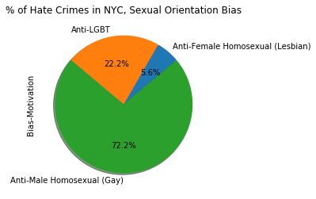

There’s no census data for LGBT population in NYC so we can estimate the population by using

Geof Gee, Robin Fisher, and Adam Looney, Joint Filing by Same-Sex Couples after Windsor: Characteristics of Married Tax Filers in 2013 and 2014

LGBT Population by borough:

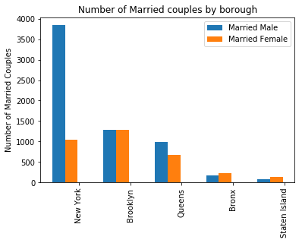

LGBT Crime by Borough

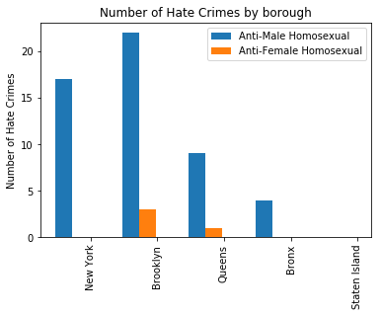

Seems like crimes against LGBT are disproportionally high in Brooklyn.

Heat map of crimes against LGBT in NYC:

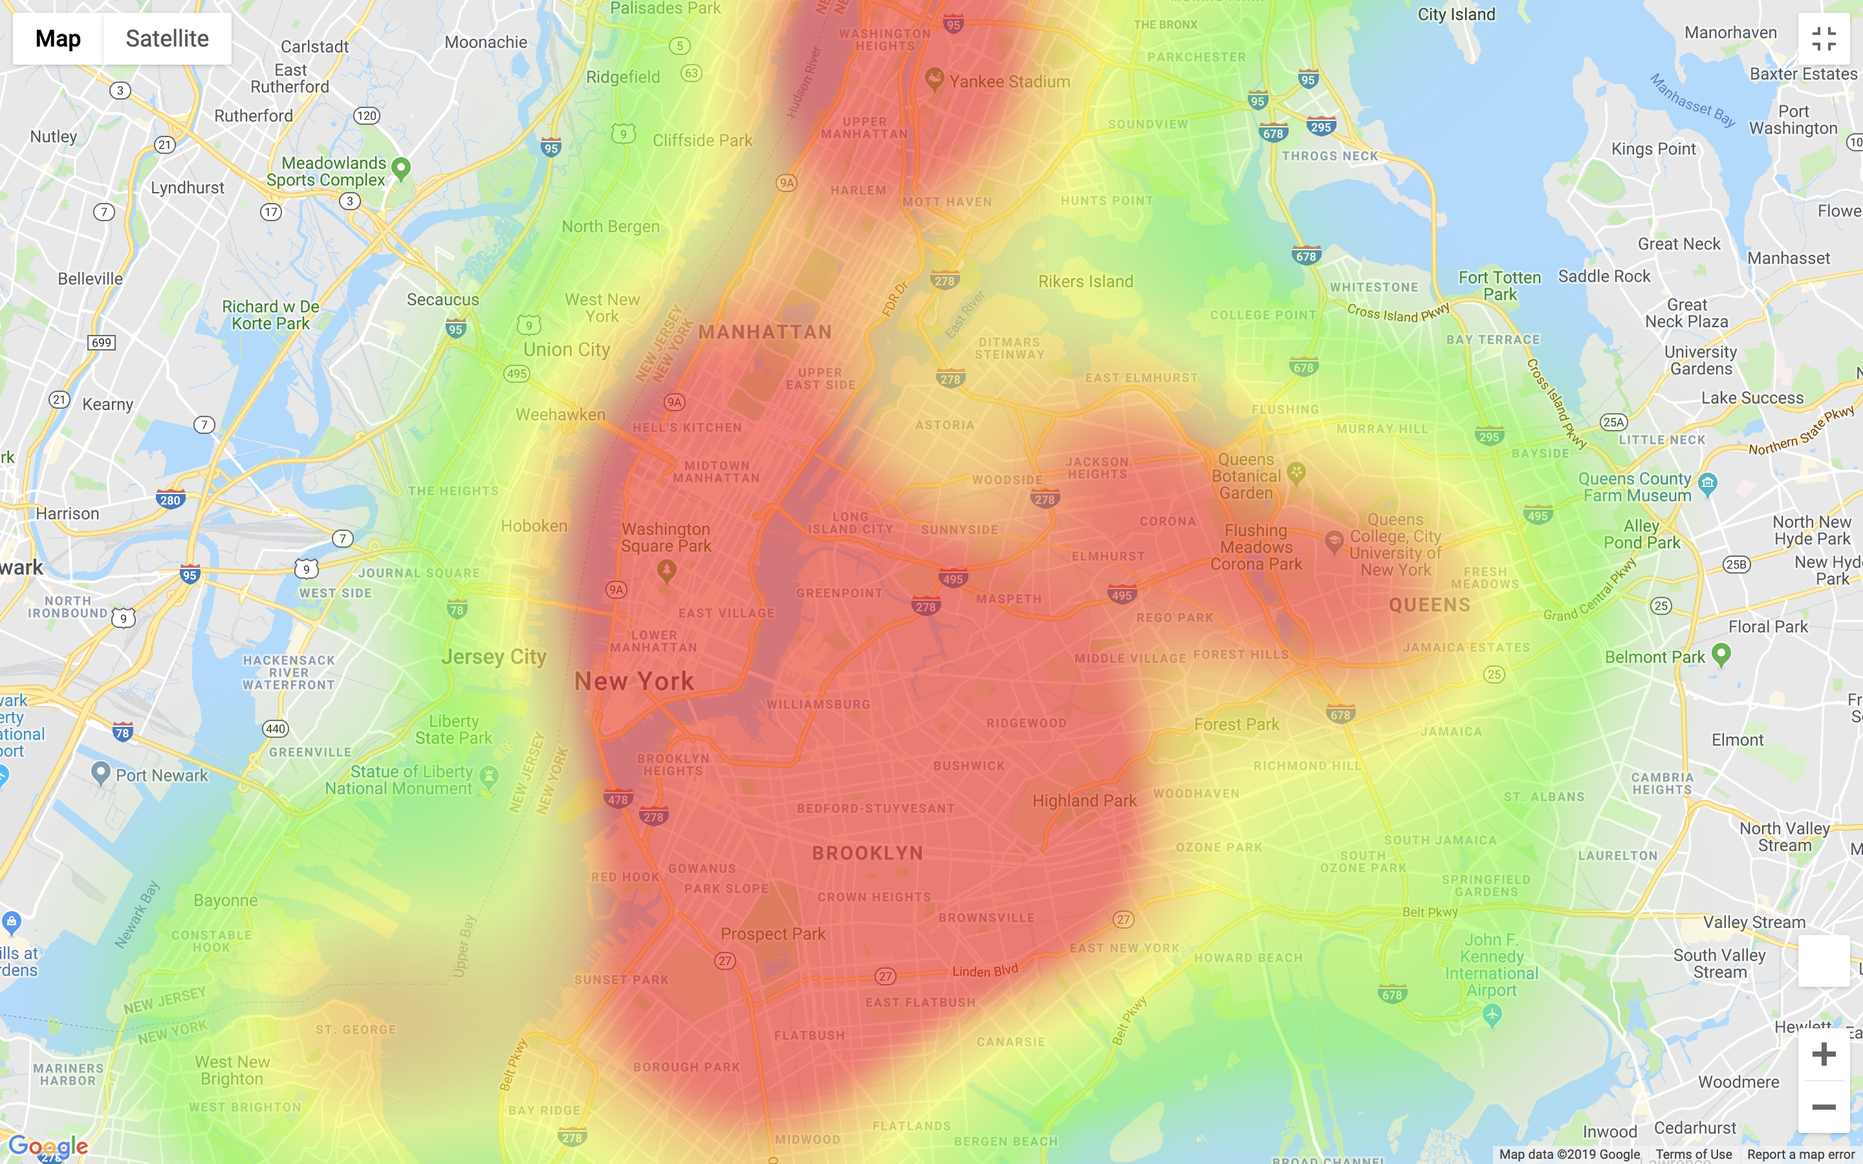

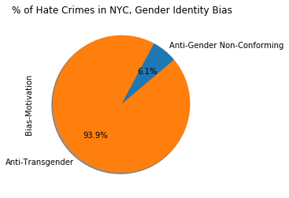

Gender Identity bias makes up 1.7% out of federal hate crime, but 8% of NYC crime. Gender Identity Bias seems to be more present in the large cities. It’s a new bias and we don’t have enough data at this point to analyze it closely by neighborhood.

Mostly against transgender people but also gender non conforming.

Summary table of crimes gender identity bias

